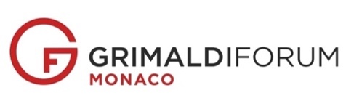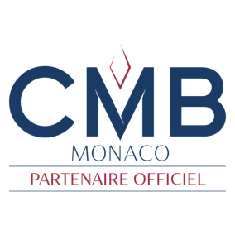

Press release

January 11, 2023

***SPONSORSHIP***

***CMB Monaco & Grimaldi Forum  
renew their partnership and make a joint commitment to CSR***

**The most Monegasque of banks is once again the official partner of the Cultural and Congress Center of the Principality! The agreement of this premium partnership extends throughout the year 2023 and includes for the first time a Social Responsibility pilot project.**

Signed by CMB Monaco Chairman Etienne Franzi and CEO Francesco Grosoli, together with Grimaldi Forum Chairman Henri Fissore and Managing Director Sylvie Biancheri, the agreement covers the Grimaldi Forum's cultural program in the Principality as well as all its business tourism activities.

While being associated with the image of the Grimaldi Forum, CMB Monaco enables the latter to develop its cultural offer and contributes to the influence of the Principality. **CMB Monaco and the Grimaldi Forum have also joined forces to promote CSR values, announcing the launch of a joint pilot project for 2023 for the benefit of the Association *Les Enfants de Frankie*. Led by CMB Monaco and Les Enfants de Frankie, groups of underprivileged children will be invited this summer to discover the Grimaldi Forum's major exhibition through guided tours with a special welcome.  
  
*For Etienne Franzi*** *" This commitment to the Grimaldi Forum, which dates back to 2005, symbolizes the confidence we have in this company and our desire to promote culture in the Principality and beyond".* ***Henri Fissore****, for his part, " particularly welcomed this mark of confidence from CMB Monaco, which has been loyal to the Grimaldi Forum for 18 years and is a true patron of the arts, contributing to the quality of our cultural productions, in particular the great summer exhibition at the Grimaldi Forum, which has become a much-anticipated international event, this year's Monet in full light, on the occasion of the 140thanniversary of the Master's first stopover in Monte-Carlo and on the Riviera.*

***Committed to CSR, CMB Monaco*** *follows a program called ToDEI, which encourages diversity, equity and inclusion, and fights against discrimination in remuneration and career development. Recently certified by the global quality control body SGS (Société Générale de Surveillance), CMB Monaco, which has 51% female employees, has obtained the Fair On Pay certificate, which distinguishes the private bank as a fair employer and underlines its sustainable commitment to equal pay.* ***Francesco Grosoli*** *underlined that " the banking industry has two main elements : technological capital on the one hand, but also and above all human capital ".*

*Certified ISO 14001 since 2008,* ***the Grimaldi Forum*** *is now part of a more global CSR approach, on the way to ISO 20121 event certification. It has just published a social responsibility charter on its website that lists all its environmental, social and solidarity-based progress and projects. Among them, the implementation of a day's work for each of its employees to benefit a civic association in the Principality, the perpetuation of telework for its employees or the eco-design of its exhibitions.*



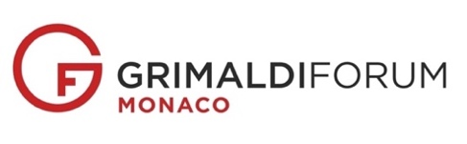**About CMB Monaco:**

CMB Monaco, a leading international private bank based in Monaco since 1976, specialises in asset investment advice and wealth management. CMB Monaco aims to be the bank of reference for Monegasque residents and offers a "boutique" approach to wealth management for international clients. It also creates opportunities in corporate and investment banking.

For more information: [www.cmb.mc](http://www.cmb.mc)

**About the Grimaldi Forum Monaco:**Recognizable by its spectacular glass and steel design, the Principalitý of Monaco's congress and cultural center offers a modular surface area of 70,000 m2 reclaimed from the sea for conventions, trade shows, galas, shows or exhibitions hosting an average of up to 3,000 people per day. This major event venue, which welcomes 250,000 visitors and over a hundred events a year, is ISO 14001 certified and has recently embarked on an ISO 20121 certification process.   
For more information : [www.grimaldiforum.com](http://www.grimaldiforum.com/)

***-----------***

***To download photos of the signing - credits Grimaldi Forum Monaco 2023 - JC Vinaj,*** [***click here***](https://www.dropbox.com/sh/axyst49f6mtpmhb/AADDV80XdJl4-BJdg4hnE3Mva?dl=0)

**Legends**

Signature : Seated at the podium, from left to right : Francesco Grosoli, Etienne Franzi, Henri Fissore and Sylvie Biancheri.

Standing, from left to right : Francesco Grosoli, Etienne Franzi, Henri Fissore and Sylvie Biancheri

***---  
Press contacts****:   
Ida Commin* [*icommin@cmb.mc*](mailto:icommin@cmb.mc)*Dany Rubrecht* [*drubrecht@grimaldiforum.com*](mailto:drubrecht@grimaldiforum.com)